Prerequirese:

1. Arduino UNO hardware
2. **Processing software (download it from:** <https://processing.org/download>)

Procedure

Step 1: Download Arduino code from Github: <https://github.com/skarantha22/Adruino_WIN_GUI_based-5_stepper-motor-function/blob/main/uno_rasp_pi.ino>

Step 2: Run this code on Arduino UNO board

Step 3: Rig up the circuit as shown in figure

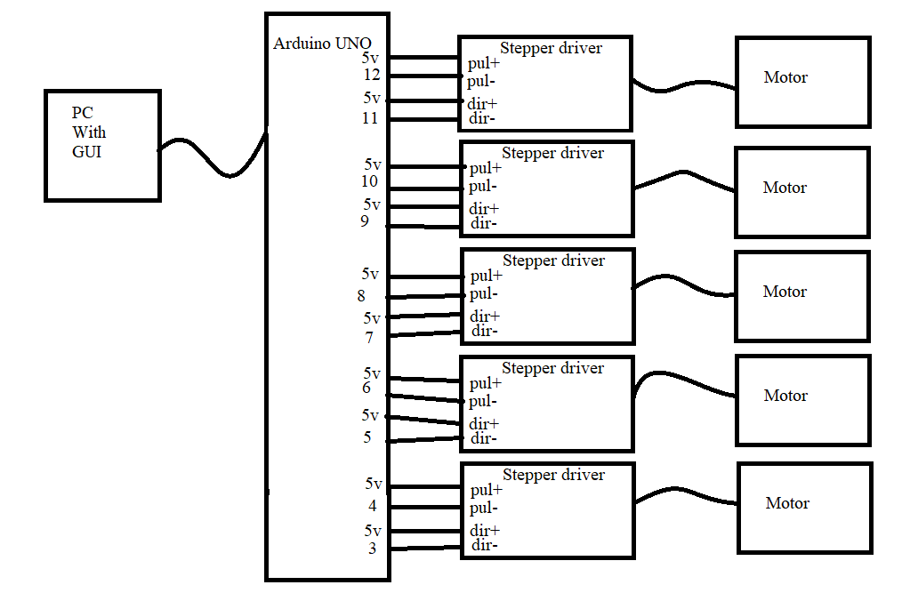

Step 4: Install Processing software.

Step 5: Import library as it is stated in video: <https://www.youtube.com/watch?v=YrRt2V1ApKE&t=89s>

Step 6: Now download GUI code from Github link: <https://github.com/skarantha22/Adruino_WIN_GUI_based-5_stepper-motor-function/blob/main/win_gui.pde>

Step 7: Find Arduino COM port and Do changes in GUI code. More details watch sample video: <https://www.youtube.com/watch?v=YrRt2V1ApKE&t=89s>

Step 8: Run program and GUI appear as shown in figure:

Step 9: Now can control stepper motor.